**Rehashing:**

There are chances of insertion failure when hash table is full, so the solution for this particular case is to create a new hash table with the double size of previous hash table. Here, we will use new hash function and we will insert all the elements of the pervious hash table. So, we will scan the elements of previous hash table one by open & calculate the hash key with new hash function & insert them into new hash table.

**Consider the table size 11 & elements are 7, 18, 43, 10, 36, 25………..**

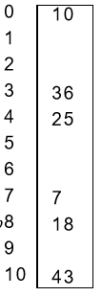Soln:-

Size = 11

Applying linear probing, we get :

h(7) = 7 mod 11= 7

h( 18) = 18 mod 11= 7

h(43) = 43 mod 11= 10

h(10) = 10 mod 11= 10

h(36) = 36 mod 11= 3

h(25) = 25 mod 11= 3

now, if we want to insert six more element then size will not be sufficient .

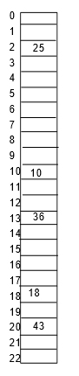In order to fit all the elements or key with in a table we take new table of size more than double with prime number.

Thus total size is 23.

Then, we get,

h(7) = 7 mod 23= 7

h(18) = 18 mod 23 = 18

h(43) = 43 mod 23 = 20

h(10) = 10 mod 23 = 10

h(36) = 36 mod 23= 13

h(25) = 25 mod 23 = 2 .. …. .. .. .. ..

Disadvantage:- This method is more expression.